**Lab Manual – Display Memory**

**Important Instructions:**

* **Make proper subroutines**
* **Use Delay Function, that we did in class (if required)**

**Activity 1 [Moving Star]:** Write a function MovingStar that shows an asterisk ‘*’ moving from Top-Left to Top-Right to Bottom-Right to Bottom-Left back to Top-Left. Your program should terminate after one round.

**Activity 2:** Update code written in activity 1 such that the star travels the screen in an infinite loop.

**Activity 3:** Code to clear screen is given in example 7.1. Your task is to modify this code and print ‘_’ (underscore) on first 13 rows of screen and ‘.’ In rest of the rows. Required output is given below. Properly calculate the cells required with each character.

**Required Output:**

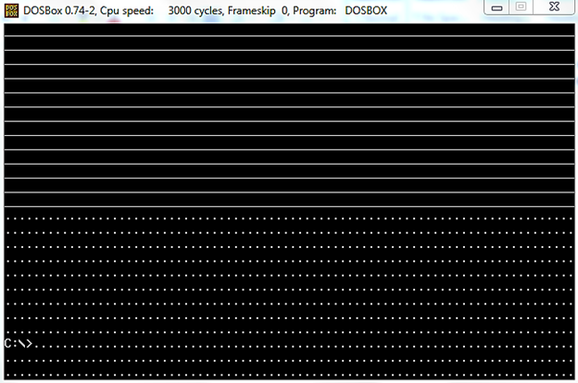

We did following code in class:

|  |
| --- |
| ; clear the screen  [org 0x0100]    mov ax, 0xb800 ; load video base in ax  mov es, ax ; point es to video base  mov di, 0 ; point di to top left column  ; es:di pointint to --> 0xB800:0000 (B8000)  nextchar: mov word [es:di], 0x0720 ; clear next char on screen  add di, 2 ; move to next screen location  cmp di, 4000 ; has the whole screen cleared  jne nextchar ; if no clear next position  mov ax, 0x4c00 ; terminate program  int 0x21 |

**Activity 4:** Update above code such that it prints all characters (ASCII 0 to 255) on screen starting from location zero onwards and fills all the screen as shown in the figure below:

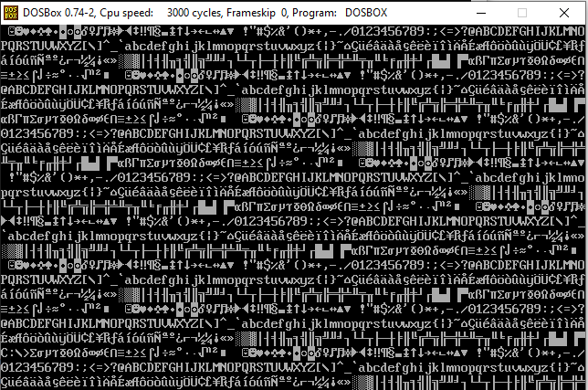

**Activity 5:** Update the code written in Question 1 to print blinking characters with high intensity as shown in the figure below:

